**TECHNOLOGY ARCHITECTURE**

**INTRODUCTION**

Since 1997 we have studied methods for adaptive on-line recognition of isolated characters. A hypothetical application in our minds has been a portable digital assistant (PDA) into which all input would be entered with a stylus. Such a system should be capable of decent recognition of any user’s writing right from the beginning and still be able to increase its accuracy during use. In our view, the adaptation of the recognizer should take place unnoticed by the user, i.e. simultaneously with the system’s normal use. In this paper, we summarize all our experiments and experiences this far. In Section 2, we first give a short overview of the recognition system. Then, in Sections 3 and 4 we describe the data used and the preprocessing and normalization stages applied in all experiments. Section 5 addresses the feature extraction methods we have utilized and Section 6 the different classification techniques we have applied. The various dissimilarity measures used in the Dynamic Time Warping (DTW) classifier are then analyzed in more depth in Section 7. As our recognition system is user-independent and adaptive, the formation of the initial prototype set and its modification during the on-line adaptation stage are essential to the operation. These questions are addressed in the next two sections. Finally, we summarize our results until now in Section 10, consider some implementation issues in Section 11, and have a look at our future plans in Section 12.

**General Overview of the System**

The recognition system used in our experiments is based on various forms of template matching. It consists of one or more separate classification units which compare input characters with their own prototype sets. If more than one classification unit are used simultaneously, they form a committee classifier. The recognition system is adapted to the new user’s writing style either by adding, inactivating, or modifying the prototypes in the individual recognizers, or by adding new, more detailed decision rules in the committee classifier. These two forms of adaptation can be carried out simultaneously or sequentially

Figure 1: Architecture of the handwriting recognition system

The overall architecture of the recognition system is illustrated in Figure 1. The information flow begins at the data collection device and goes through the preprocessing and normalization units before it reaches the recognition unit. The recognition unit is adapted according to validated recognition result which is the output of the system. Figure 2 describes the recognition unit in more detail. Various classification techniques have been experimented with. These include Dynamic Time Warping, matching of symbol strings, and non-parametric statistical classification based on the k-Nearest Neighbor rule and the Local Subspace Classification rule.

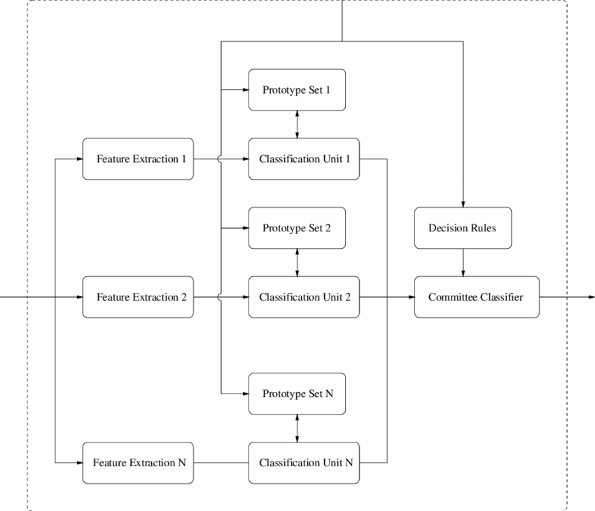

Figure 2: Architecture of the recognizer unit

The recognition system is adapted on-line and in a self-supervised fashion. The correct classes of the input characters are deduced from both the recognition results and the user’s actions. The initial prototype set of each classifier is formed by clustering character samples written by several subjects. Therefore, it covers multiple writing styles already at the beginning of the use. Completely new writing styles can be learned quickly when characters input by the user are added into the prototype set as such. In addition, the existing prototypes can be gradually reshaped so that they better represent the user’s style of writing. This adaptation is carried out with an algorithm based on Learning Vector Quantization (LVQ). Prototypes which are confusing and are therefore more harmful than useful can be inactivated. The decision rule of a committee classifier is initially as simple as majority-voting. New decision rules are produced according to Dynamically Expanding Context (DEC) principle . This technique adds new decision rules whenever the existing rules fail to correctly classify an input character. The new rules utilize more information on the outputs of the committee members and are thus more specific than the original ones.